

**COMP 1640**

**Enterprise Web Application Development**

Group Members:

P.D.A.L. Wickramasinghe - 001074749

L.H.S.U.S. Abeywardana - 001047070

Contents

1. Introduction 4

1.1. Team Members and Roles 4

1.2. URL for group Repository 5

1.3. URL for Site 5

1.4. URL for ScreenCast 5

1.5. Group Member Evaluation 5

2. Background 6

3. The Requirements 7

4. Database Design and Implementation 8

4.1. ER Diagram and assumptions 8

4.2 Normalization 9

5. Site Design and Implementation 10

5.1. Use Case Diagram 10

5.2. UI Design 11

6. Testing Methodology 17

6.1. Test Plan 17

6.2. Test Log 20

7. Agile Methodology 23

7.1. User Stories 23

7.2. Product Backlog 25

7.3. Sprint 1 27

7.3.1. Sprint Backlog 27

7.3.2. Burn Down Chart 28

7.3.3. Meeting Minutes 28

7.4. Sprint 2 29

7.4.1. Sprint Backlog 29

7.4.2. Burn Down Chart 30

7.4.3. Meeting Minutes 30

7.5. Sprint 3 31

7.5.1. Sprint Backlog 31

7.5.2. Burn Down Chart 32

7.5.3. Meeting Minutes 32

7.6. Sprint 4 33

7.6.1. Sprint Backlog 33

7.6.2. Burn Down Chart 34

7.6.3. Meeting Minutes 34

7.7. Sprint 5 35

7.7.1. Sprint Backlog 35

7.7.2. Burn Down Chart 36

7.7.3. Meeting Minutes 36

7.8. Sprint 6 37

7.8.1. Sprint Backlog 37

7.8.2. Burn Down Chart 38

7.8.3. Meeting Minutes 38

7.9. Sprint 7 39

7.9.1. Sprint Backlog 39

7.9.2. Burn Down Chart 40

7.9.3. Meeting Minutes 40

7.10. Sprint 8 41

7.10.1 Spring Backlog 41

7.10.2 Burn Down Chart 42

7.10.3 Meeting Minutes 42

7.11 Sprint 9 43

7.11.1 Sprint Backlog 43

7.11.2 Burn Down Chart 44

7.11.3 Meeting Minutes 44

7.12 Sprint 10 45

7.12.1 Sprint Backlog 45

7.12.2 Burn Down Chart 46

7.12.3 Meeting Minutes 46

# Introduction

Scrum is a framework within which people can address complex adaptive problems, while productively and creatively delivering products of the highest possible value. Scrum process is highly flexible and interactive methodology, and always welcome changes. Each sprint is planned to be one week of time. Because of it’s ideal for in-house development.

|  |  |
| --- | --- |
| Scrum Team | |
| Scrum Master | The sprint backlog, use-case, burndown charts & recording of meeting minutes have been made by our scrum master. |
| Database Designer | The entity relationship diagram and the database implementation were made by our database designer. |
| Developers | The entire system was developed by our 3 developers. |
| Quality Assurance Planner | The test plan & test logs were made by our quality assurance planner. |

Table 1

## Team Members and Roles

P.D.A.L. Wickramasinghe - Database Designer/ Developer/ UI Designer

L.H.S.U.S. Abeywardana - Scrum Master/ Quality Assurance Planner

## URL for group Repository

## URL for Site

## URL for ScreenCast

## Group Member Evaluation

|  |  |
| --- | --- |
| Weight Factor | |
| Work | |
| * Punctuality | 7 |
| * Completeness | 8 |
| * Accuracy | 8 |
| Performance as a Team Member | |
| * Responding to the communication | 6 |
| * Collaboration | 7 |
| * Physical Attendance | 9 |

Table 1.2 Weight Factors

# Background

The course work required to build a web-based secure role-based system for eTutoring in a large university. Our web application, provide a facility for the student to upload articles, blogging, messaging with the tutor. Also the tutor can collaborate with student through our website both parties can arrange meeting from our website and they can record it. The system has 3 user roles. Admin, Student and the tutor. The system will generate reports from past statistics such as no of message with the tutor, Average number of messages for each personal tutor.

# The Requirements

* All students must have a personal tutor.
* Any authorised member of staff can allocate or reallocate personal tutors to students. The student and the personal tutors will get notification emails when this happens.
* Bulk allocation of students to their personal tutor (eg 10 at a time) needs to be implemented.
* All students and their tutors are to use the eTutor system for messaging, arranging and recording meetings (both real and virtual), uploading documents and commenting on them, and for blogging.
* Email between students and their personal tutors is to be used only for notification of events recorded in the backend database. No other content is to be sent via email.
* Student and staff data is accessed from the university MIS system. The maintenance of this is outside the scope of this project.
* Each student will have their own personal dashboard summarising their interaction with their personal tutor.
* Each personal tutor will have a dashboard of their personal tutees that can be sorted and filtered appropriately
* Authorised staff will have access to the dashboards of other staff, and to individual dashboards for students.
* The interface must be suitable for all devices (eg. mobile phones, tablets, desktops)
* Reports:-
* Statistics
  + Number of messages in last 7 days
  + Average number of messages for each personal tutor
* Exception reports
  + Students without a personal tutor.
  + Students with no interaction for 7 days and 28 days.

# Database Design and Implementation

## ER Diagram and assumptions

1

Figure 4.1ER Diagram

## 4.2 Normalization

Figure 4.2Normalization Table

# Site Design and Implementation

## Use Case Diagram

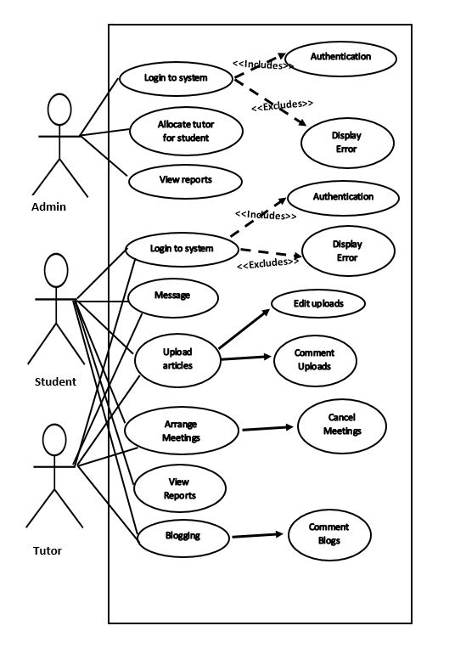

Figure 5 Use Case Diagram

## UI Design

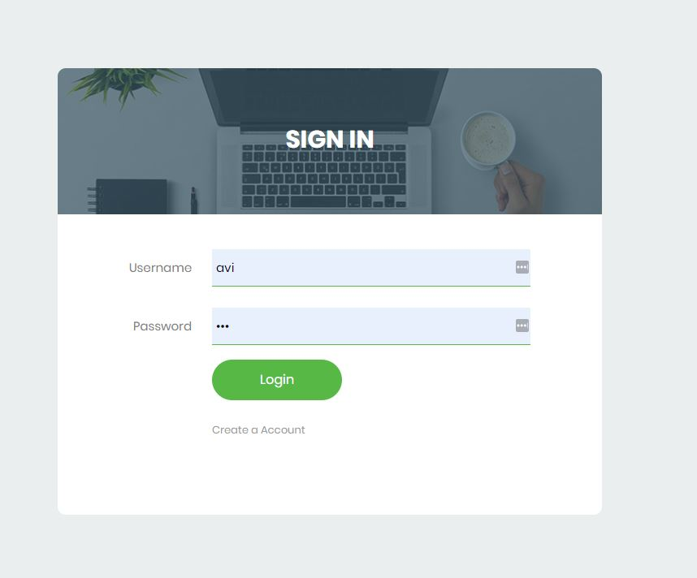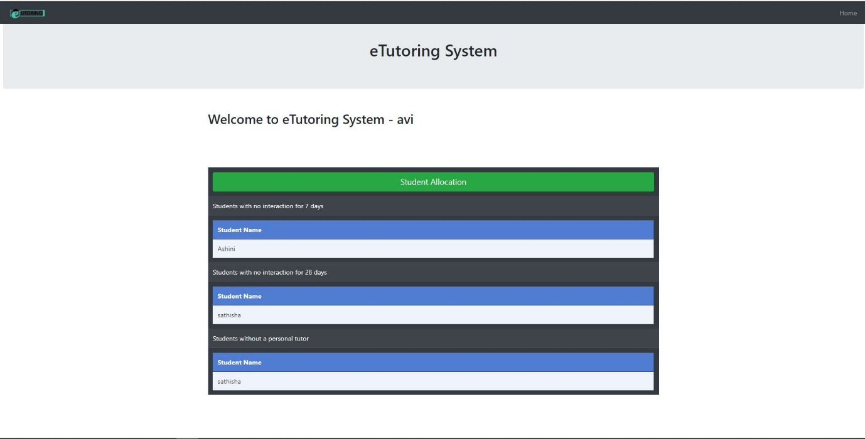

Figure 5.2 Admin Panel

Figure 5.1 Login Page

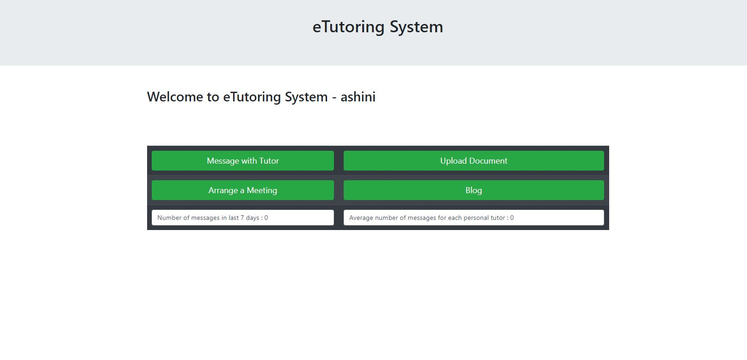

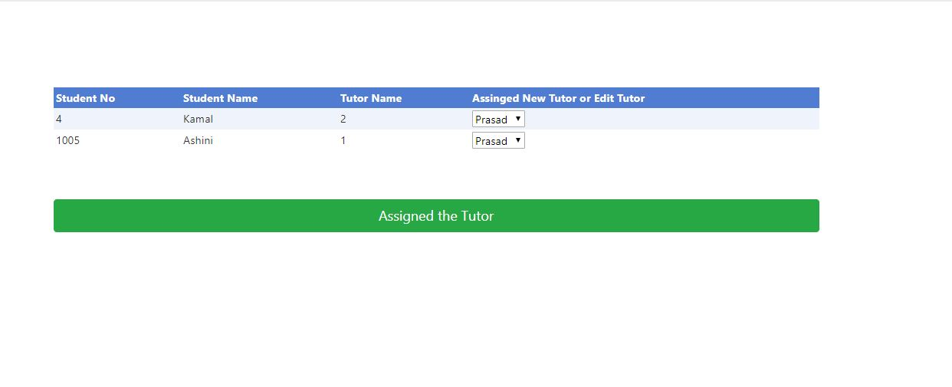

Figure 5.4 Student Panel

Figure 5.3 Tutor Allocation

Figure 5.6 Upload articles page for student

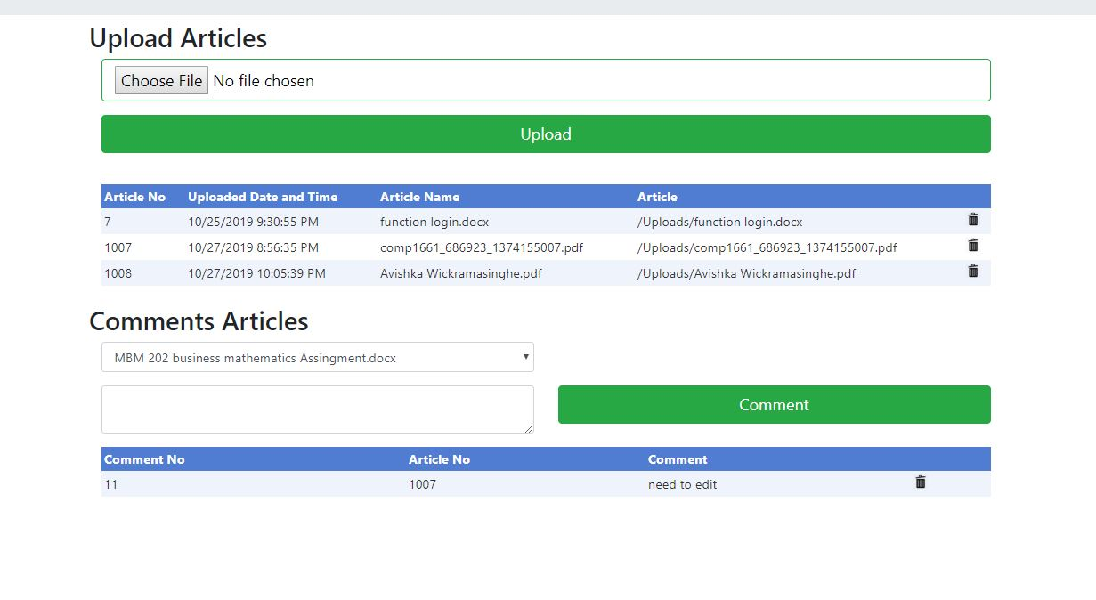

Figure 5.5 Message with Student

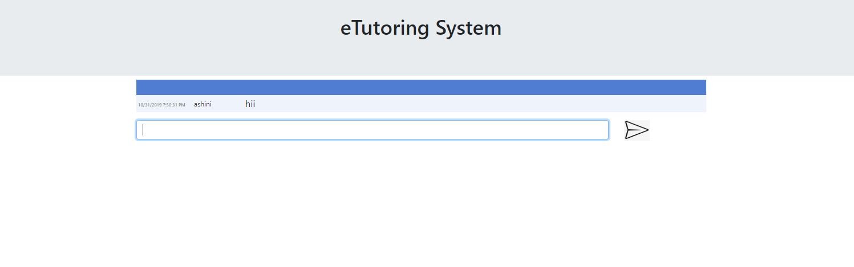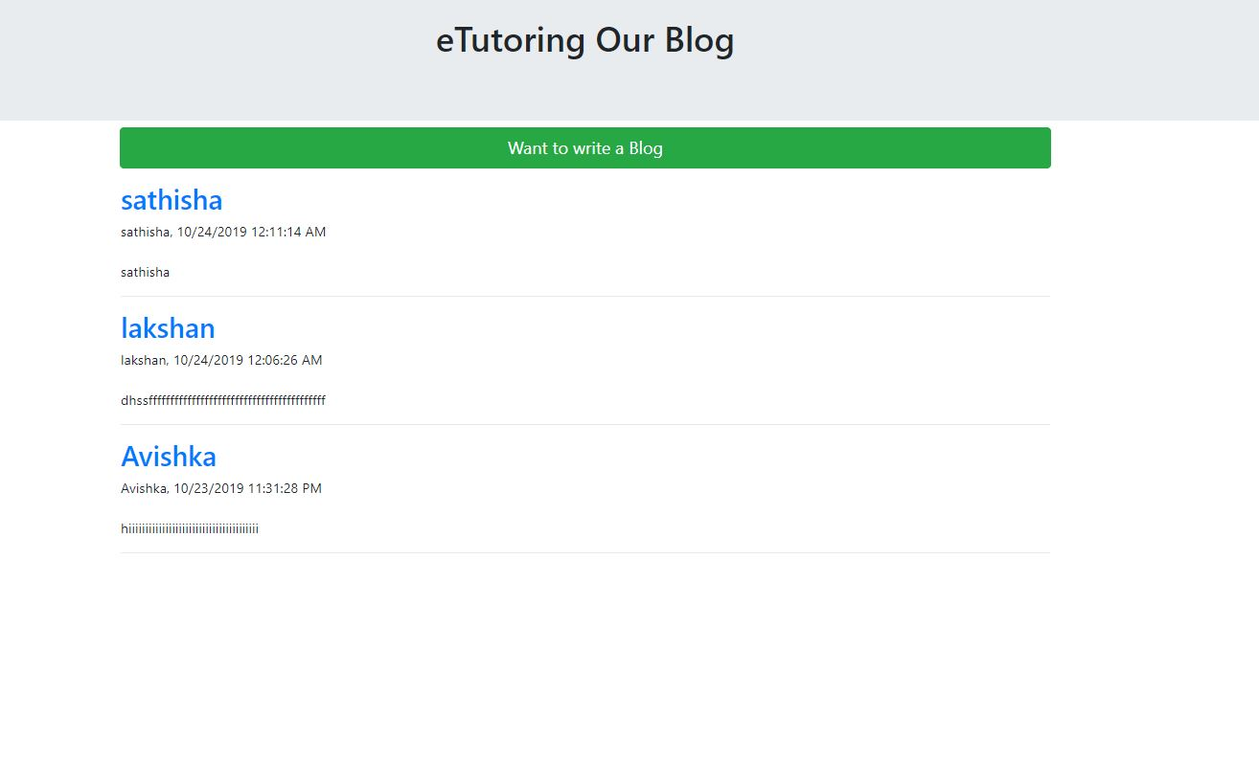

Figure 5.8 Blogging page

Figure 5.7 Arrange meeting with tutor

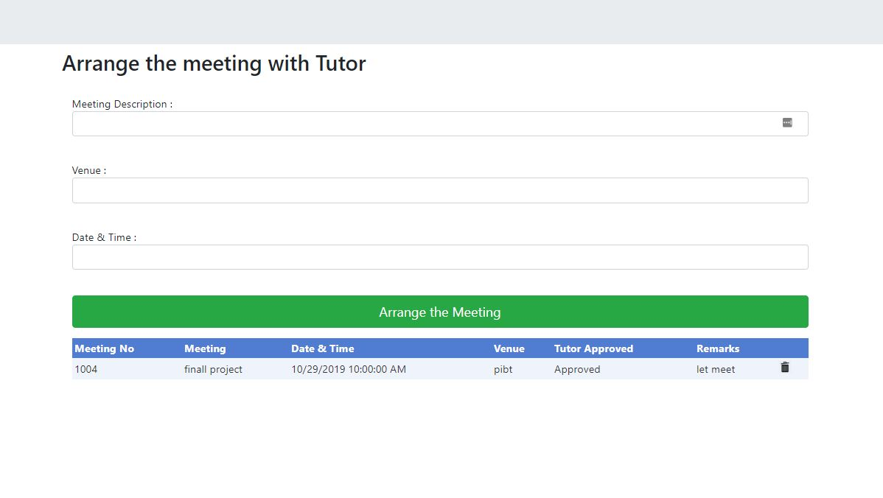

Figure 5.10 Tutor Page - Messaging part

Figure 5.9 inside a blog

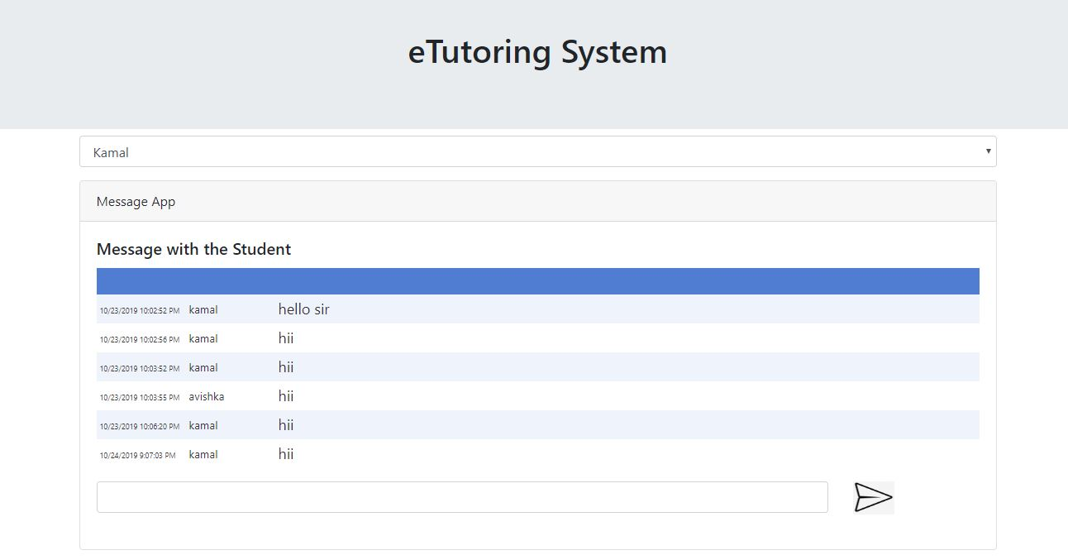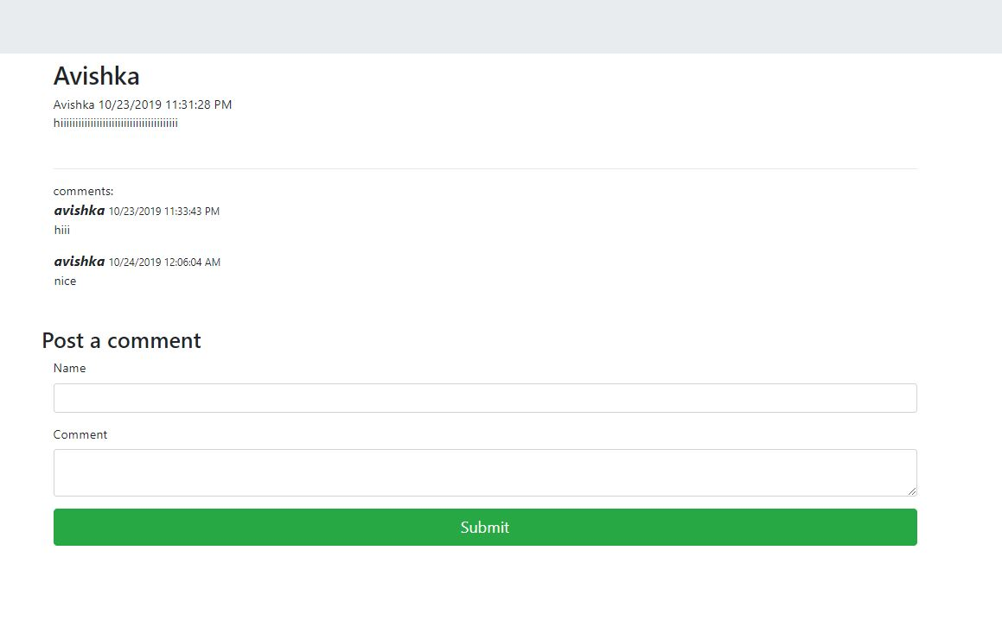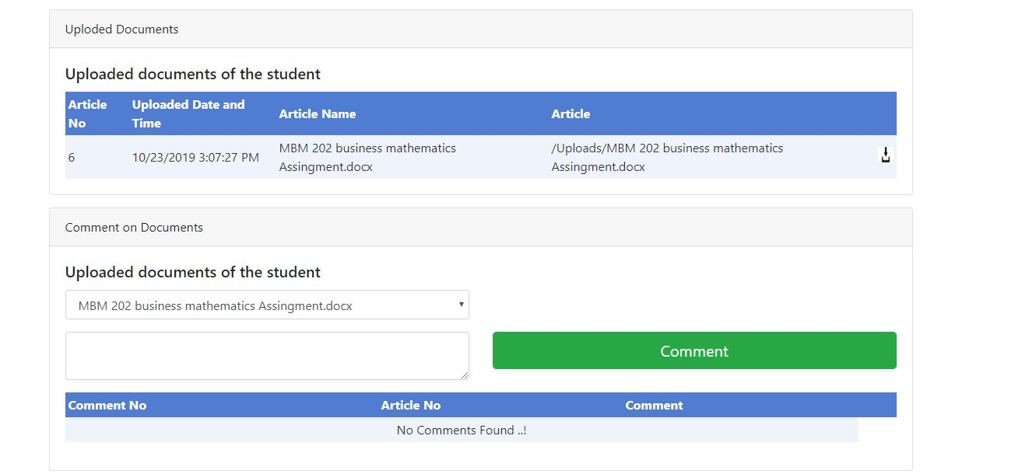

Figure 5.12 Tutor Page - Article part

Figure 5.11 Tutor Page - Arrange Meeting part

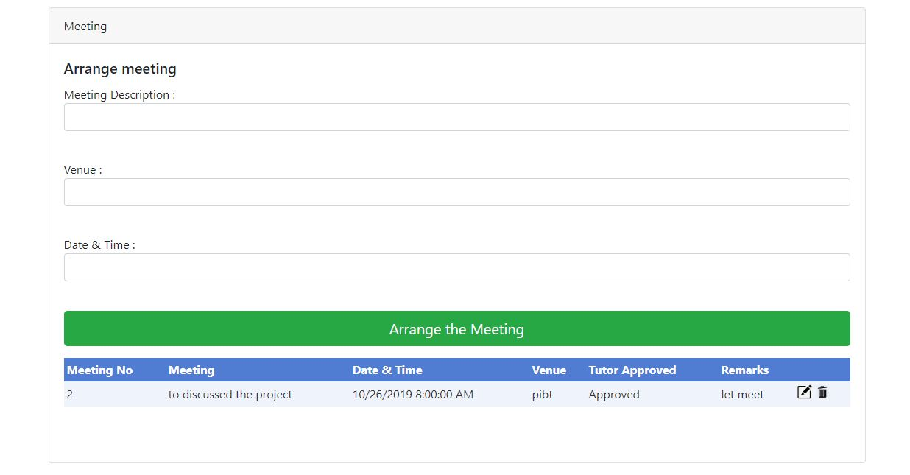

# Testing Methodology

## Test Plan

|  |  |  |  |  |
| --- | --- | --- | --- | --- |
| Test case #ID | Test Title | Test scenarios | User logins used for testing | Expected result |
| 01 | Verify the user registration for user login. | (a) Enter completed details with Sign Up.  (b) Enter incomplete details with Sign Up. | Student  Tutor  Admin | User should be able to see welcome message and user should be able to see login page.  (Successfully Registration) |
| 02 | Verify the login functionality of login page. | (a)Enter a valid and user name and password for login to the system.  (b) Enter an invalid and user name and wrong password for login to the system. | Student  Tutor  Admin | System should be able to accept valid password then user should be able to see available functions. As well as system should be able to reject invalid password. And system should be able to show error message. |
| 03 | Verify the user role for login the page. | Login into the system using the different main level of job roles (2).  1.Student  2. Tutor | Student  Tutor  Admin  Tutor | System should be able to give access to different main level user roles logins (2). |
| 04 | Verify student logins. | (a)Access to login the system using student login. | Student  Admin | System should be able to accept valid student logins and access to documents & massages. |
| 05 | Verify student logins with ability to arrange meetings with tutor | (a) Access to login the system using student login.  (b) Arranging meetings from the same student login. | Student  Admin | System should be able to manage (a) & (b) from each student login. |
| 06 | Verify student logins with ability to upload Documents / Articles. | (a) Access to login the system using student login.  (b)Uploading the documents / Articles within text from the same student login. | Student  Admin  Student  Admin | System should be able to accept upload documents / Articles within text. |
| 07 | Verify massaging with tutor and student | (a) Access to login the system using student login.  (b) Ability to send e mails or massages to tutor and or student. | Student  Admin | The system should be able to provide the requested facilities |
| 08 | Verify facility for blog | (a) Access to login the system using student login for blog | Student  Admin | User should be able to use the facility for blog |
| 09 | Verify massages with tutor by student | Number of massages communicated with tutor within last 7 days | Student  Tutor  Admin | User should be able to see number of massages communicated |
| 10 | Verify status of meeting arranged with tutor | Details of meeting arranged | Student  Tutor  Admin | User should be able to see the meetings arranged with the tutor |
| 11  12 | Verify information of meetings arranged by the student is communicated to the tutor  Verify to see the system provides names of allocated students to tutor | The tutor should be able to see the meetings arranged by each student  The tutor should be able to see his students allocated | Student  Tutor  Admin | The tutor should provide detail information on meetings arranged by students  The tutor should provide names of allocated students |
| 13 | Verify status of uploaded documents by the students | The tutor should be able to see the documents uploaded | Tutor  Admin | The tutor should provide information of uploaded documents by the students |
| 14 | Verify system facility for comments on documents uploaded | The tutor should be able to make comments on the documents uploaded | Tutor  Admin | Provisions should be given to the tutor on same |
| 15 | Verify status on communication made by tutor | The student should be able to receive comments made by tutor | Student  Admin | The system should provide student a facility to see the comments made by tutor |

## Test Log

|  |  |  |  |  |  |  |  |
| --- | --- | --- | --- | --- | --- | --- | --- |
| Test case #ID | Test Title | Test scenarios | Expected result | Actual Result | Tested Date | Pass/ Fail/Expected/ Not Expected | Action Taken |
| 01 | Verify the user registration for user login. | (a) Enter completed details with Sign Up.  (b) Enter incomplete details with Sign Up. | User should be able to see welcome message and user should be able to see login page.  (Successfully Registration) | (a)System accepted correct data with complete details.  (b)System rejected incorrect data with incomplete details. | 28 Oct 2019 | Pass |  |
| 02 | Verify the login functionality of login page. | (a)Enter a valid and user name and password for login to the system.  (b) Enter an invalid and user name and wrong password for login to the system. | System should be able to accept valid password then user should be able to see available functions. As well as system should be able to reject invalid password. And system should be able to show error message. | (a)System accepted valid and correct username and password.  (a)System rejected invalid and incorrect username and password.(error message) | 28 Oct 2019 | Pass |  |
| 03 | Verify the user role for login the page. | Login into the system using the different main level of job roles (2).  1.Student  2. Tutor | System should be able to give access to different main level user roles logins (2). | System accepted all the different levels of user roles. | 28 Oct 2019 | Pass |  |
| 04 | Verify student logins. | (a)Access to login the system using student login. | System should be able to accept valid student logins and access to documents & massages. | System accepted valid student logins to manage them | 28 Oct 2019 | Pass |  |
| 05 | Verify student logins with ability to arrange meetings with tutor | (a) Access to login the system using student login.  (b) Arranging meetings from the same student login. | System should be able to manage (a) & (b) from each student login. | System accepted valid student logins to manage them. | 28 Oct 2019 | Pass |  |
| 06 | Verify student logins with ability to upload Documents / Articles. | (a) Access to login the system using student login.  (b)Uploading the documents / Articles within text from the same student login. | System should be able to accept upload documents / Articles within text. | System accepted valid student logins to upload documents / Articles. | 29 Oct 2019 | Pass |  |
| 07 | Verify massaging with tutor and student | (a) Access to login the system using student login.  (b) Ability to send e mails or massages to tutor and or student. | The system should be able to provide the requested facilities | The system provides the facility for both the Tutor and the Student | 29 Oct 2019 | failed | Corrected |
| 08 | Verify facility for blog | (a) Access to login the system using student login for blog | User should be able to use the facility for blog | The system provides the facility | 29 Oct 2019 | Pass |  |
| 09 | Verify massages with tutor by student | Number of massages communicated with tutor within last 7 days | User should be able to see number of massages communicated | The system provides number of massages communicated with the tutor | 29 Oct 2019 | Pass |  |
| 10 | Verify status of meeting arranged with tutor | Details of meeting arranged | User should be able to see the meetings arranged with the tutor | The system provides the information of meetings arranged | 29 Oct 2019 | Pass |  |
| 11  12 | Verify information of meetings arranged by the student is communicated to the tutor  Verify to see the system provides names of allocated students to tutor | The tutor should be able to see the meetings arranged by each student  The tutor should be able to see his students allocated | The tutor should provide detail information on meetings arranged by students  The tutor should provide names of allocated students | The system provides the required information on the meetings of each student  The system provides the names of allocated students to the tutor | 29 Oct 2019  29 Oct 2019 | Pass  Pass |  |
| 13 | Verify status of uploaded documents by the students | The tutor should be able to see the documents uploaded | The tutor should provide information of uploaded documents by the students | The system provides the information of uploaded documents | 29 Oct 2019 | Pass |  |
| 14 | Verify system facility for comments on documents uploaded | The tutor should be able to make comments on the documents uploaded | Provisions should be given to the tutor on same | The system provides the provisions and facility for comments by the tutor | 29 Oct 2019 | Pass |  |
| 15 | Verify status on communication made by tutor | The student should be able to receive comments made by tutor | The system should provide student a facility to see the comments made by tutor | The system provides the student the facility to see the comments made by the tutor | 29 Oct 2019 | Pass |  |

# Agile Methodology

## User Stories

|  |  |  |
| --- | --- | --- |
| ID | User | User Story |
| 01 | Admin | As an Admin, I need to sign in to my account, So that I can communicate with my tutor. |
| 02 | Admin | As an Admin, I want to allocate tutors for students, So that they can communicate |
| 03 | A Student | As a Student, I need to sign in to my account, So that I can communicate with my tutor. |
| 04 | A Student | As a Student, I need to message with my tutor, So that I can communicate with my tutor. |
| 05 | A Student | As a Student, I need to Upload documents, So that I can show my documents to my tutor. |
| 06 | A student | As a student, I need to see my uploads, So that I can comment on it. |
| 07 | A student | As a student, I need to delete my uploads, So that I can re-edit and upload it. |
| 08 | A student | As a student, I need to delete my comments, So that I can re-comment on it. |
| 09 | A student | As a Student, I need to arrange meetings and record meeting, So that I can manage the meetings. |
| 10 | A student | As a Student, I need to cancel meetings, So that I can change the meetings. |
| 11 | A Tutor | As a Tutor, I need to sign in to my account, So that I can communicate with my students. |
| 12 | A Tutor | As a Tutor, I need to message with my Student, So that I can communicate with my student. |
| 13 | A Tutor | As a Tutor, I need to download uploaded documents, So that I can see the documents. |
| 14 | A Tutor | As a Tutor, I need to see students uploaded documents, So that I can comment on it. |
| 15 | A Tutor | As a Tutor, I need to delete my comments, So that I can re-comment on it. |
| 16 | A Tutor | As a Tutor, I need blogging, So that I can share my thoughts with others. |
| 17 | A Student | As a Student, I need blogging, So that I can share my thoughts with others. |
| 18 | An Admin | As an Admin, I have access to the dashboard of staff and students, So that I can help to both parties. |
| 19 | A Student | As a Student, I want to know the number of messages in last 7 days, So that I can get an idea about how I communicate with my Tutor |
| 20 | A Tutor | As a Tutor, I want to know the number of messages in last 7 days, So that I can get an idea about how I communicate with my Student |
| 21 | A Student | As a Student, I want to know the average number of messages for each personal tutor, So that I can get an idea about how I communicate with my Tutor |
| 22 | An Admin | As an Admin, I want to know students that doesn’t have a personal tutor, So that I can appoint a tutor |
| 23 | An Admin | As an Admin, I want to know students with no interaction for 7 days and 28 days, So that I can give feedbacks. |
| 24 | A Tutor | As a Tutor, I need to arrange meetings and record meeting, So that I can manage the meetings. |
| 25 | A Student | As a Student, I need to request a tutor, So that I can communicate with tutor |
| 26 | Users | As a User, I need a secure website, so that I can share everything |
| 27 | User | As a User, I need to store all related things, So that I can retrieve easily. |

## Product Backlog

|  |  |  |  |  |
| --- | --- | --- | --- | --- |
| ID | Requirement | Story ID | Feature | Priority |
| 01 | A database should be design to store all the records | 27 | Database design | 01 |
| 02 | All users should have separate logins to their accounts | 01 | Login Interface | 02 |
| 03 | Implement secure data transfer via encrypted channel using SSL | 26 | Secure data transfer channel | 03 |
| 04 | Student can see their home page | 03 | Student Home Page | 04 |
| 05 | Student should able to upload, delete his uploads and comments added | 05  06  07  08 | Student Upload Page | 06 |
| 06 | Student should message with their tutor. | 04 | Student Message Page | 07 |
| 07 | Students should able to arrange Meetings and cancel meeting | 09  10 | Student Meeting Page | 08 |
| 08 | Student should have to blog | 17 | Blogging Page | 09 |
| 09 | Tutor can select and filter with the student | 11 | Tutor Page | 10 |
| 10 | Tutor should message with their student. | 12 | Tutor Page | 11 |
| 11 | Tutor should able to view, delete his uploads and comments added | 13  14  15 | Tutor Page | 12 |
| 12 | Tutor should able to arrange Meetings and cancel meeting | 24 | Tutor Page | 13 |
| 13 | System should able generate statistical reports including | 19  20  21  22  23 | Reports generation | 16 |
| 14 | Admin have access to dashboards of students and staff | 18 | Admin Page | 15 |
| 15 | Admin can allocate tutors to students | 02 | Student allocation page | 17 |
| 16 | Student can request a tutor | 25 | Student Request page | 05 |
| 17 | Tutor should have to blog | 16 | Blog Page | 14 |

## Sprint 1

### Sprint Backlog

|  |  |  |  |  |  |  |  |  |  |  |
| --- | --- | --- | --- | --- | --- | --- | --- | --- | --- | --- |
| Task No | Description | Name | Role |  | Remaining hours as end of | | | | | Remaining hours |
| Committed hours | Day 01 | Day 02 | Day 03 | Day 04 | Day 05 |
| 1 | Requirement clarification of web application with team | Savani | Product owner | 6 | 5 | 5 | 2 | 2 | 0 | 0 |
| 2 | Discussion of Product backlog items with Scrum master | Savani | Product owner | 2 | 2 | 0 | 0 | 0 | 0 | 0 |
| 3 | Verification of Product backlog items | Savani | Product owner | 1 | 1 | 1 | 1 | 0 | 0 | 0 |
| 4 | Preparation of product backlog | Savani | Scrum master | 2 | 2 | 2 | 2 | 2 | 0 | 0 |
| 5 | Requirement clarification for login screen | Savani | Scrum master | 1 | 1 | 1 | 0 | 0 | 0 | 0 |
| 6 | Discussion on test plane and test schedule with QA | Savani | Scrum master | 4 | 3 | 2 | 2 | 0 | 0 | 0 |
| 7 | Prepare test plans | Savani | QA | 3 | 3 | 3 | 2 | 2 | 0 | 0 |
| 8 | Prepare test schedules | Savani | QA | 2 | 2 | 2 | 2 | 0 | 0 | 0 |
| 9 | Prepare conceptual & logical designs of Database | Avishka | Database designer | 3 | 2 | 1 | 1 | 1 | 0 | 0 |
| 10 | Discussion of database design with scrum master | Avishka | Database designer | 1 | 1 | 1 | 0 | 0 | 0 | 0 |
| 11 | Develop the physical database for the prerared design | Avishka | Database designer | 2 | 2 | 0 | 0 | 0 | 0 | 0 |
| 12 | Login form back-end programming | Avishka | Programmer1 | 5 | 5 | 3 | 3 | 2 | 0 | 0 |
| 13 | Discussion of login process with database designer | Avishka | Programmer1 | 1 | 1 | 1 | 1 | 0 | 0 | 0 |
| 14 | Setup database connectivity with login | Avishka | Programmer1 | 1 | 1 | 0 | 0 | 0 | 0 | 0 |
| 15 | Discussion of security features to be included in login with scrum master | Avishka | Programmer1 | 1 | 0 | 0 | 0 | 0 | 0 | 0 |
| 16 | Discussion of security features to be included in login with database designer | Avishka | Programmer1 | 1 | 1 | 0 | 0 | 0 | 0 | 0 |
| 17 | Implementing required security features on login | Avishka | Programmer1 | 2 | 2 | 2 | 0 | 0 | 0 | 0 |
| 18 | Login screen layout design | Avishka | Programmer1 | 1 | 1 | 0 | 0 | 0 | 0 | 0 |
| 19 | Login screen UI design | Avishka | Programmer1 | 3 | 1 | 0 | 0 | 0 | 0 | 0 |

### Burn Down Chart

### Meeting Minutes

Sprint start date: 26th of August 2019

Sprint end date: 01st of September 2019

Venue: PIBT

Participants: Avishka

Savini

Meeting Minutes:

Discussed user stories and turn them into regular items. Divided among the agile team. According to the product, the backlog team decided the estimated time for each and every item, planned to finish all the items in product backlog within 10 sprints. All the members are agreed to work 3hrs per day and 7 days per week. According to that 2 members may complete 42hrs per week.

## Sprint 2

### Sprint Backlog

|  |  |  |  |  |  |  |  |  |  |  |
| --- | --- | --- | --- | --- | --- | --- | --- | --- | --- | --- |
| Task No | Description | Name | Role |  | Remaining hours as end of | | | | | Remaining hours |
| Allocated hours | Day 01 | Day 02 | Day 03 | Day 04 | Day 05 |
| 1 | Verification of sprint backlogs | Savani | Product owner | 2 | 2 | 2 | 0 | 0 | 0 | 0 |
| 2 | Verification of test results with QA | Savani | Product owner | 1 | 1 | 1 | 1 | 1 | 0 | 0 |
| 3 | Discussion on findings of test results with Scrum master | Savani | Product owner | 3 | 3 | 2 | 2 | 0 | 0 | 0 |
| 4 | Preparation of sprint backlog | Savani | Scrum master | 3 | 3 | 0 | 0 | 0 | 0 | 0 |
| 5 | Discussion and finalizing the features and layout of login screen | Savani | Scrum master | 1 | 1 | 1 | 1 | 0 | 0 | 0 |
| 6 | Discussion on test results and required changes of login with developers & QA | Savani | Scrum master | 2 | 2 | 2 | 2 | 2 | 0 | 0 |
| 7 | Prepare test cases for test Student Home & Message App | Savani | QA | 2 | 2 | 2 | 0 | 0 | 0 | 0 |
| 8 | Test the Student Home & Message App using advocate test cases | Savani | QA | 5 | 5 | 5 | 3 | 3 | 0 | 0 |
| 9 | Documenting test results | Savani | QA | 2 | 2 | 2 | 2 | 2 | 0 | 0 |
| 10 | Design the table to Student Home & message app | Avishka | Database designer | 2 | 2 | 2 | 2 | 0 | 0 | 0 |
| 11 | Implement SQL functions related to Student Home & message app | Avishka | Database designer | 3 | 3 | 3 | 3 | 3 | 0 | 0 |
| 12 | Fixing of bugs reported on test results | Avishka | Programmer1 | 2 | 2 | 0 | 0 | 0 | 0 | 0 |
| 13 | Implement the UI design for Student Home | Avishka | Programmer1 | 2 | 2 | 2 | 2 | 0 | 0 | 0 |
| 14 | Implement the UI design for Student Message App | Avishka | Programmer1 | 2 | 0 | 0 | 0 | 0 | 0 | 0 |
| 15 | Backend code for Student home | Avishka | Programmer1 | 3 | 3 | 1 | 0 | 0 | 0 | 0 |
| 16 | Backend code for Message app | Avishka | Programmer1 | 3 | 3 | 0 | 0 | 0 | 0 | 0 |
| 17 | Testing the Student Home | Avishka | Programmer1 | 2 | 2 | 2 | 2 | 2 | 0 | 0 |
| 18 | Testing the Student Message app | Avishka | Programmer1 | 2 | 2 | 2 | 2 | 0 | 0 | 0 |

### Burn Down Chart

### Meeting Minutes

Sprint start date: 02nd of September 2019

Sprint end date: 08th of September 2019

Venue: PIBT

Participants: Avishka

Savini

Meeting Minutes:

Discussed drawbacks of the first sprint and all the members understood that we need to move a little bit fast to achieve the goal within the given limited time period. The development has started with user Login page, Student home page with messaging facility and ready to move to the testing from next sprint.

## Sprint 3

### Sprint Backlog

|  |  |  |  |  |  |  |  |  |  |  |
| --- | --- | --- | --- | --- | --- | --- | --- | --- | --- | --- |
| Task No | Description | Name | Role |  | Remaining hours as end of | | | | | Remaining hours |
| Allocated hours | Day 01 | Day 02 | Day 03 | Day 04 | Day 05 |
| 1 | Verification of sprint backlogs | Savani | Product owner | 1 | 1 | 1 | 1 | 1 | 0 | 0 |
| 2 | Verification of test results with QA | Savani | Product owner | 2 | 2 | 2 | 0 | 0 | 0 | 0 |
| 3 | Discussion on findings of test results with Scrum master | Savani | Product owner | 3 | 3 | 2 | 2 | 0 | 0 | 0 |
| 4 | Preparation of sprint backlog | Savani | Scrum master | 3 | 3 | 0 | 0 | 0 | 0 | 0 |
| 5 | Discussion and finalizing the features and layout | Savani | Scrum master | 2 | 2 | 1 | 1 | 0 | 0 | 0 |
| 6 | Discussion on test results and required changes with developers & QA | Savani | Scrum master | 2 | 2 | 2 | 2 | 2 | 0 | 0 |
| 7 | Prepare test cases for test Student Upload documents & Meeting page | Savani | QA | 2 | 2 | 2 | 0 | 0 | 0 | 0 |
| 8 | Test the Upload documents & Meeting page using advocate test cases | Savani | QA | 5 | 5 | 5 | 3 | 3 | 0 | 0 |
| 9 | Documenting test results | Savani | QA | 2 | 2 | 2 | 2 | 2 | 0 | 0 |
| 10 | Design the table to Upload documents & Meeting page | Avishka | Database designer | 2 | 2 | 2 | 2 | 0 | 0 | 0 |
| 11 | Implement SQL functions related to Upload documents & Meeting page | Avishka | Database designer | 3 | 3 | 3 | 3 | 3 | 0 | 0 |
| 12 | Fixing of bugs reported on test results | Avishka | Programmer1 | 2 | 2 | 0 | 0 | 0 | 0 | 0 |
| 13 | Implement the UI design for Upload documents | Avishka | Programmer1 | 2 | 2 | 2 | 2 | 0 | 0 | 0 |
| 14 | Implement the UI design for Meeting page | Avishka | Programmer1 | 2 | 0 | 0 | 0 | 0 | 0 | 0 |
| 15 | Backend code for Upload documents | Avishka | Programmer1 | 3 | 3 | 1 | 0 | 0 | 0 | 0 |
| 16 | Backend code for Meeting page | Avishka | Programmer1 | 3 | 3 | 0 | 0 | 0 | 0 | 0 |
| 17 | Testing the Upload documents | Avishka | Programmer1 | 2 | 2 | 2 | 2 | 2 | 0 | 0 |
| 18 | Testing the Meeting page | Avishka | Programmer1 | 2 | 2 | 2 | 2 | 0 | 0 | 0 |

### Burn Down Chart

### Meeting Minutes

Sprint start date: 09th of September 2019

Sprint end date: 15th of September 2019

Venue: PIBT

Participants: Avishka

Savini

Meeting Minutes:

Discussed what the drawbacks of the previous sprint are. UI Design for upload documents and Meeting page screen was discussed and developed. Testing the upload documents and Meeting page functions & UI.

## Sprint 4

### Sprint Backlog

|  |  |  |  |  |  |  |  |  |  |  |
| --- | --- | --- | --- | --- | --- | --- | --- | --- | --- | --- |
| Task No | Description | Name | Role |  | Remaining hours as end of | | | | | Remaining hours |
| Allocated hours | Day 01 | Day 02 | Day 03 | Day 04 | Day 05 |
| 1 | Verification of sprint backlogs | Savani | Product owner | 3 | 3 | 3 | 2 | 1 | 0 | 0 |
| 2 | Verification of test results with QA | Savani | Product owner | 2 | 2 | 2 | 2 | 2 | 0 | 0 |
| 3 | Discussion on findings of test results with Scrum master | Savani | Product owner | 1 | 1 | 0 | 0 | 0 | 0 | 0 |
| 4 | Preparation of sprint backlog | Savani | Scrum master | 3 | 2 | 2 | 0 | 0 | 0 | 0 |
| 5 | Discussion and finalizing the features and layout | Savani | Scrum master | 1 | 1 | 1 | 1 | 1 | 0 | 0 |
| 6 | Discussion on test results and required changes with developers & QA | Savani | Scrum master | 2 | 2 | 2 | 2 | 0 | 0 | 0 |
| 7 | Prepare test cases for test Student Blogging | Savani | QA | 3 | 3 | 2 | 2 | 2 | 0 | 0 |
| 8 | Test the Blogging page using advocate test cases | Savani | QA | 4 | 4 | 4 | 3 | 2 | 0 | 0 |
| 9 | Documenting test results | Savani | QA | 2 | 2 | 2 | 2 | 0 | 0 | 0 |
| 10 | Design the table to Upload Blogging page | Avishka | Database designer | 3 | 3 | 2 | 1 | 0 | 0 | 0 |
| 11 | Implement SQL functions related toBlogging page | Avishka | Database designer | 5 | 5 | 4 | 3 | 1 | 0 | 0 |
| 12 | Fixing of bugs reported on test results | Avishka | Programmer1 | 3 | 3 | 1 | 0 | 0 | 0 | 0 |
| 13 | Implement the UI design for Blogging page | Avishka | Programmer1 | 4 | 4 | 3 | 1 | 0 | 0 | 0 |
| 14 | Backend code for Blogging page | Avishka | Programmer1 | 3 | 3 | 3 | 2 | 1 | 0 | 0 |
| 15 | Testing the Blogging page | Avishka | Programmer1 | 3 | 3 | 3 | 2 | 0 | 0 | 0 |

### Burn Down Chart

### Meeting Minutes

Sprint start date: 16th of September 2019

Sprint end date: 22nd of September 2019

Venue: PIBT

Participants: Avishka

Savini

Meeting Minutes:

Discussed what the drawbacks of the previous sprint are. Fixed the reported bugs of document upload page functions. UI Design for Blogging page screen was discussed and designed it.

## Sprint 5

### Sprint Backlog

|  |  |  |  |  |  |  |  |  |  |  |
| --- | --- | --- | --- | --- | --- | --- | --- | --- | --- | --- |
| Task No | Description | Name | Role |  | Remaining hours as end of | | | | | Remaining hours |
| Allocated hours | Day 01 | Day 02 | Day 03 | Day 04 | Day 05 |
| 1 | Verification of sprint backlogs | Savani | Product owner | 1 | 0 | 0 | 0 | 0 | 0 | 0 |
| 2 | Verification of test results with QA | Savani | Product owner | 2 | 2 | 2 | 0 | 0 | 0 | 0 |
| 3 | Discussion on findings of test results with Scrum master | Savani | Product owner | 3 | 3 | 2 | 2 | 0 | 0 | 0 |
| 4 | Preparation of sprint backlog | Savani | Scrum master | 3 | 3 | 0 | 0 | 0 | 0 | 0 |
| 5 | Discussion and finalizing the features and layout | Savani | Scrum master | 2 | 0 | 0 | 0 | 0 | 0 | 0 |
| 6 | Discussion on test results and required changes with developers & QA | Savani | Scrum master | 2 | 2 | 2 | 2 | 2 | 0 | 0 |
| 7 | Prepare test cases for test Tutor page & Tutor message page | Savani | QA | 2 | 2 | 2 | 2 | 0 | 0 | 0 |
| 8 | Test the Tutor page & Tutor message page using advocate test cases | Savani | QA | 5 | 5 | 5 | 3 | 3 | 0 | 0 |
| 9 | Documenting test results | Savani | QA | 2 | 2 | 2 | 2 | 2 | 0 | 0 |
| 10 | Design the table toTutor page & Tutor message page | Avishka | Database designer | 2 | 2 | 2 | 2 | 0 | 0 | 0 |
| 11 | Implement SQL functions related to Tutor page & Tutor message page | Avishka | Database designer | 3 | 3 | 3 | 3 | 3 | 0 | 0 |
| 12 | Fixing of bugs reported on test results | Avishka | Programmer1 | 2 | 2 | 0 | 0 | 0 | 0 | 0 |
| 13 | Implement the UI design for Tutor Page | Avishka | Programmer1 | 2 | 2 | 2 | 2 | 0 | 0 | 0 |
| 14 | Implement the UI design for Tutor Message page | Avishka | Programmer1 | 2 | 0 | 0 | 0 | 0 | 0 | 0 |
| 15 | Backend code for Tutor Page | Avishka | Programmer1 | 3 | 3 | 1 | 0 | 0 | 0 | 0 |
| 16 | Backend code for Tutor Message page | Avishka | Programmer1 | 3 | 3 | 0 | 0 | 0 | 0 | 0 |
| 17 | Testing theTutor Page | Avishka | Programmer1 | 2 | 2 | 0 | 0 | 0 | 0 | 0 |
| 18 | Testing the Tutor Message page | Avishka | Programmer1 | 2 | 2 | 2 | 2 | 0 | 0 | 0 |

### Burn Down Chart

### Meeting Minutes

Sprint start date: 23rd of September 2019

Sprint end date: 29th of September 2019

Venue: PIBT

Participants: Avishka

Savini

Meeting Minutes:

Discussed what the drawbacks of the previous sprint are. Relevant test cases and test plans were introduced. Tutor page & Tutor message page section development was taken into a discussion and came up with few modifications.

## Sprint 6

### Sprint Backlog

|  |  |  |  |  |  |  |  |  |  |  |
| --- | --- | --- | --- | --- | --- | --- | --- | --- | --- | --- |
| Task No | Description | Name | Role |  | Remaining hours as end of | | | | | Remaining hours |
| Allocated hours | Day 01 | Day 02 | Day 03 | Day 04 | Day 05 |
| 1 | Verification of sprint backlogs | Savani | Product owner | 1 | 0 | 0 | 0 | 0 | 0 | 0 |
| 2 | Verification of test results with QA | Savani | Product owner | 2 | 2 | 2 | 2 | 0 | 0 | 0 |
| 3 | Discussion on findings of test results with Scrum master | Savani | Product owner | 3 | 3 | 2 | 1 | 0 | 0 | 0 |
| 4 | Preparation of sprint backlog | Savani | Scrum master | 3 | 3 | 3 | 2 | 0 | 0 | 0 |
| 5 | Discussion and finalizing the features and layout | Savani | Scrum master | 2 | 1 | 1 | 1 | 1 | 0 |  |
| 6 | Discussion on test results and required changes with developers & QA | Savani | Scrum master | 2 | 2 | 2 | 0 | 0 | 0 |  |
| 7 | Prepare test cases for test tutor uploaded documents & tutor Meeting page | Savani | QA | 2 | 2 | 2 | 2 | 2 | 0 | 0 |
| 8 | tutor uploaded documents & tutor Meeting page using advocate test cases | Savani | QA | 5 | 5 | 5 | 3 | 0 | 0 | 0 |
| 9 | Documenting test results | Savani | QA | 2 | 2 | 1 | 1 | 1 | 0 | 0 |
| 10 | Design the table to tutor uploaded documents & tutor Meeting page | Avishka | Database designer | 2 | 2 | 2 | 2 | 0 | 0 | 0 |
| 11 | Implement SQL functions related to tutor uploaded documents & tutor Meeting page | Avishka | Database designer | 3 | 3 | 2 | 2 | 2 | 0 | 0 |
| 12 | Fixing of bugs reported on test results | Avishka | Programmer1 | 2 | 2 | 0 | 0 | 0 | 0 | 0 |
| 13 | Implement the UI design for Tutor Upload page | Avishka | Programmer1 | 2 | 2 | 2 | 2 | 0 | 0 |  |
| 14 | Implement the UI design for Tutor Meeting page | Avishka | Programmer1 | 2 | 0 | 0 | 0 | 0 | 0 |  |
| 15 | Backend code for Tutor Uploaded Page | Avishka | Programmer1 | 3 | 3 | 1 | 0 | 0 | 0 | 0 |
| 16 | Backend code for Tutor Meeting page | Avishka | Programmer1 | 3 | 3 | 0 | 0 | 0 | 0 | 0 |
| 17 | Testing the Tutor Uploaded Page | Avishka | Programmer1 | 2 | 2 | 0 | 0 | 0 | 0 |  |
| 18 | Testing the Tutor Meeting page | Avishka | Programmer1 | 2 | 2 | 2 | 2 | 0 | 0 | 0 |

### Burn Down Chart

### Meeting Minutes

Sprint start date: 30th of September 2019

Sprint end date: 6th of October 2019

Venue: PIBT

Participants: Avishka

Savini

Meeting Minutes:

Discussed what the drawbacks of the previous sprint are. Tutor downloaded the students upload functions will be given to a QA manager.

## Sprint 7

### Sprint Backlog

|  |  |  |  |  |  |  |  |  |  |  |
| --- | --- | --- | --- | --- | --- | --- | --- | --- | --- | --- |
| Task No | Description | Name | Role |  | Remaining hours as end of | | | | | Remaining hours |
| Allocated hours | Day 01 | Day 02 | Day 03 | Day 04 | Day 05 |
| 1 | Verification of sprint backlogs | Savani | Product owner | 3 | 3 | 3 | 2 | 1 | 0 | 0 |
| 2 | Verification of test results with QA | Savani | Product owner | 2 | 2 | 2 | 2 | 2 | 0 | 0 |
| 3 | Discussion on findings of test results with Scrum master | Savani | Product owner | 1 | 1 | 0 | 0 | 0 | 0 | 0 |
| 4 | Preparation of sprint backlog | Savani | Scrum master | 3 | 2 | 2 | 0 | 0 | 0 | 0 |
| 5 | Discussion and finalizing the features and layout | Savani | Scrum master | 1 | 1 | 1 | 1 | 1 | 0 | 0 |
| 6 | Discussion on test results and required changes with developers & QA | Savani | Scrum master | 2 | 2 | 2 | 2 | 0 | 0 | 0 |
| 7 | Prepare test cases for test Statistical Reports | Savani | QA | 3 | 3 | 2 | 2 | 2 | 0 | 0 |
| 8 | Test the Statistical Reports using advocate test cases | Savani | QA | 4 | 4 | 4 | 3 | 2 | 0 | 0 |
| 9 | Documenting test results | Savani | QA | 2 | 2 | 2 | 2 | 0 | 0 | 0 |
| 10 | Design the table to Statistical Reports | Avishka | Database designer | 3 | 3 | 2 | 1 | 0 | 0 | 0 |
| 11 | Implement SQL functions related to Statistical Reports | Avishka | Database designer | 5 | 5 | 4 | 3 | 1 | 0 | 0 |
| 12 | Fixing of bugs reported on test results | Avishka | Programmer1 | 3 | 3 | 1 | 0 | 0 | 0 | 0 |
| 13 | Implement the UI design for Statistical Reports | Avishka | Programmer1 | 4 | 4 | 3 | 1 | 0 | 0 | 0 |
| 14 | Backend code for Statistical Reports | Avishka | Programmer1 | 3 | 3 | 3 | 2 | 1 | 0 | 0 |
| 15 | Testing the Statistical Reports | Avishka | Programmer1 | 3 | 3 | 3 | 2 | 0 | 0 | 0 |

### Burn Down Chart

### Meeting Minutes

Sprint start date: 7th of October 2019

Sprint end date: 13th of October 2019

Venue: PIBT

Participants: Avishka

Savini

Meeting Minutes:

Discussed what the drawbacks of the previous sprint are. Statistical report functions had some issues that needed to be clear and take it to fix.

## Sprint 8

### Spring Backlog

|  |  |  |  |  |  |  |  |  |  |  |
| --- | --- | --- | --- | --- | --- | --- | --- | --- | --- | --- |
| Task No | Description | Name | Role |  | Remaining hours as end of | | | | | Remaining hours |
| Allocated hours | Day 01 | Day 02 | Day 03 | Day 04 | Day 05 |
| 1 | Verification of sprint backlogs | Savani | Product owner | 1 | 1 | 1 | 1 | 1 | 0 | 0 |
| 2 | Verification of test results with QA | Savani | Product owner | 2 | 2 | 1 | 0 | 0 | 0 | 0 |
| 3 | Discussion on findings of test results with Scrum master | Savani | Product owner | 3 | 3 | 3 | 2 | 1 | 0 | 0 |
| 4 | Preparation of sprint backlog | Savani | Scrum master | 3 | 2 | 2 | 1 | 0 | 0 | 0 |
| 5 | Discussion and finalizing the features and layout | Savani | Scrum master | 4 | 2 | 2 | 0 | 0 | 0 | 0 |
| 6 | Discussion on test results and required changes with developers & QA | Savani | Scrum master | 2 | 2 | 2 | 2 | 2 | 0 | 0 |
| 7 | Prepare test cases for test Admin panel | Savani | QA | 3 | 3 | 2 | 2 | 1 | 0 | 0 |
| 8 | Test the Admin panel using advocate test cases | Savani | QA | 1 | 1 | 1 | 1 | 0 | 0 | 0 |
| 9 | Documenting test results | Savani | QA | 2 | 2 | 2 | 2 | 1 | 0 | 0 |
| 10 | Design the table to Admin panel | Avishka | Database designer | 3 | 3 | 2 | 1 | 0 | 0 | 0 |
| 11 | Implement SQL functions related to Admin panel | Avishka | Database designer | 5 | 5 | 4 | 3 | 1 | 0 | 0 |
| 12 | Fixing of bugs reported on test results | Avishka | Programmer1 | 3 | 3 | 1 | 0 | 0 | 0 | 0 |
| 13 | Implement the UI design for Admin panel | Avishka | Programmer1 | 4 | 4 | 3 | 1 | 0 | 0 | 0 |
| 14 | Backend code for Admin panel | Avishka | Programmer1 | 3 | 3 | 3 | 2 | 1 | 0 | 0 |
| 15 | Testing the Admin panel | Avishka | UI designer | 3 | 3 | 3 | 2 | 0 | 0 | 0 |

### Burn Down Chart

### Meeting Minutes

Sprint start date: 14th of October 2019

Sprint end date: 20th of October 2019

Venue: PIBT

Participants: Avishka

Savini

Meeting Minutes:

Discussed what the drawbacks of the previous sprint are. Rreported bugs for Statistical report function will be taken to this sprint. Re-test the fixed bugs of article download function & UI.

## Sprint 9

### Sprint Backlog

|  |  |  |  |  |  |  |  |  |  |  |
| --- | --- | --- | --- | --- | --- | --- | --- | --- | --- | --- |
| Task No | Description | Name | Role |  | Remaining hours as end of | | | | | Remaining hours |
| Allocated hours | Day 01 | Day 02 | Day 03 | Day 04 | Day 05 |
| 1 | Verification of sprint backlogs | Savani | Product owner | 1 | 1 | 1 | 1 | 1 | 0 | 0 |
| 2 | Verification of test results with QA | Savani | Product owner | 2 | 2 | 1 | 0 | 0 | 0 | 0 |
| 3 | Discussion on findings of test results with Scrum master | Savani | Product owner | 3 | 3 | 3 | 2 | 1 | 0 | 0 |
| 4 | Preparation of sprint backlog | Savani | Scrum master | 3 | 2 | 2 | 1 | 0 | 0 | 0 |
| 5 | Discussion and finalizing the features and layout | Savani | Scrum master | 4 | 2 | 2 | 0 | 0 | 0 | 0 |
| 6 | Discussion on test results and required changes with developers & QA | Savani | Scrum master | 2 | 2 | 2 | 2 | 2 | 0 | 0 |
| 7 | Prepare test cases for test the all system | Savani | QA | 3 | 3 | 2 | 2 | 1 | 0 | 0 |
| 8 | Test the System using advocate test cases | Savani | QA | 1 | 1 | 1 | 1 | 0 | 0 | 0 |
| 9 | Documenting test results | Savani | QA | 2 | 2 | 2 | 2 | 1 | 0 | 0 |
| 10 | Fixing of bugs reported on last sprint | Avishka | Programmer1 | 4 | 4 | 3 | 2 | 0 | 0 | 0 |
| 11 | Finalize the UI designs in the system | Avishka | Programmer1 | 5 | 5 | 3 | 3 | 2 | 0 | 0 |
| 12 | Finalize the backend code for the system | Avishka | Programmer1 | 4 | 4 | 4 | 2 | 2 | 0 | 0 |
| 13 | Finalize the database in the system | Avishka | Database designer | 5 | 5 | 3 | 3 | 2 | 0 | 0 |
| 14 | Implement the database backup system | Avishka | Database designer | 3 | 3 | 3 | 2 | 2 | 0 | 0 |

### Burn Down Chart

### Meeting Minutes

Sprint start date: 21st of October 2019

Sprint end date: 27th of October 2019

Venue: PIBT

Participants: Avishka

Savini

Meeting Minutes:

Discussed what the drawbacks of the previous sprint are. Come up with the implementation.

## Sprint 10

### Sprint Backlog

|  |  |  |  |  |  |  |  |  |  |  |
| --- | --- | --- | --- | --- | --- | --- | --- | --- | --- | --- |
| Task No | Description | Name | Role |  | Remaining hours as end of | | | | | Remaining hours |
| Allocated hours | Day 01 | Day 02 | Day 03 | Day 04 | Day 05 |
| 1 | Verification of sprint backlogs | Savani | Product owner | 2 | 1 | 1 | 1 | 1 | 0 | 0 |
| 2 | Verification of test results with QA | Savani | Product owner | 2 | 2 | 1 | 0 | 0 | 0 | 0 |
| 3 | Discussion on findings of test results with Scrum master | Savani | Product owner | 3 | 3 | 3 | 2 | 1 | 0 | 0 |
| 4 | Preparation of sprint backlog | Savani | Scrum master | 3 | 2 | 2 | 1 | 0 | 0 | 0 |
| 5 | Discussion and finalizing the System | Savani | Scrum master | 4 | 2 | 2 | 0 | 0 | 0 | 0 |
| 6 | Discussion on implemention | Savani | Scrum master | 3 | 2 | 2 | 2 | 2 | 0 | 0 |
| 7 | Documenting the user manual | Savani | Scrum master | 4 | 3 | 2 | 2 | 1 | 0 | 0 |
| 10 | implement the database | Avishka | Database designer | 6 | 6 | 4 | 2 | 0 | 0 | 0 |
| 11 | implement the system | Avishka | Programmer1 | 7 | 7 | 6 | 5 | 3 | 0 | 0 |
| 12 | implement a backup method | Avishka | Database designer | 3 | 3 | 1 | 0 | 0 | 0 | 0 |
| 13 | Finalaize the system | Avishka | Programmer1 | 5 | 4 | 3 | 1 | 0 | 0 | 0 |

### Burn Down Chart

### Meeting Minutes

Sprint start date: 28th of October 2019

Sprint end date: 3rd of November 2019

Venue: PIBT

Participants: Avishka

Savini

Meeting Minutes:

Discussed what the drawbacks of the previous sprint and implement the new system.